Screen Shot
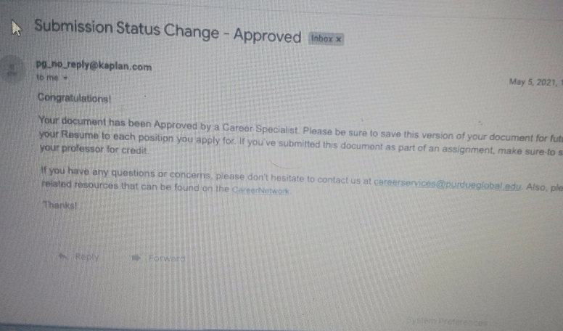

Cover Letter

COVER LETTER
MICHAEL BOATENG
955 Primus Court, Frederick, MD 21703
mboatengusn@gmail.com
+1 240-772-4079
24/03/2021
The hiring manager,
SNMMI.

Dear Hiring Manager,
I am writing in response to the recent advertisement for the Nuclear Medicine Technologist job. As an enthusiastic and compassionate Licensed Practice Nurse with ten years of experience in the specialty field of cardiology, I am confident I would be an asset to the team at your company.
As an expert at planning effective nuclear drugs for patients who need scans, I pay close attention to detail and have extensive experience performing scans for physicians. My good interpersonal and communication skills allow me to help put patients at ease while preparing them to experience a somewhat traumatic experience. I also have a Certification in security+ and AWS. I love being able to contribute actively and positively to a patient's holistic treatment, from pre-diagnosis to aftercare.
I am confident that I will be an excellent candidate for the role of Nuclear Medicine Technologist, and I am confident that you will agree upon meeting with me. Please contact me to schedule an interview. I look forward to your call.
Thank you so much for your time and consideration.

Sincerely,

Michael Boateng

Resume
MICHAEL BOATENG
955 Primus Court, Frederick, MD 21703
mboatengusn@gmail.com
240-772-4079

PROFESSIONAL SUMMARY
I am an enthusiastic and compassionate Licensed Registered Nurse (LPN) with ten years of experience in the specialty field of cardiology nursing care. I have good communication, teaching, and mentoring skills. I am seeking a part-time position in an outpatient setting.
EDUCATION
- Purdue University Global (Online) - 2021
- Bachelor of Science in Health Care Administration
GPA - 3.87
- Thomas Edison (Online) – 2016
- Bachelor of Science in Nuclear Medicine Technologist
GPA- 3.68
- Frederick Community College (Frederick Maryland) – 2014 Associate in General Studies
GPA – 3.90
- Navy Medical Training Support Center (San Antonio, Texas) – 2011
Licensed Practice Nurse GPA – 3.80
- Navy Field Medical Training Battalion (Camp Lejeune, North Carolina) – 2007
GPA – 3.60

PROFESSIONAL EXPERIENCE
- United States Navy
- Leading Petty office (LPO) 06/15 – 08/19
- In charge of scheduling
- Patient assignments
- Mentorship for sailor
- Career counselor
- Instructor/program manager for basic life support (BLS)
- Combat medic
TECHNICAL SKILLS
Certification in security+, Amazon Web Services (AWS)

Thought Description
I am ecstatic and over the moon for the positive feedback and eagerly waiting for my official appointment. My core values in life have been adaptability and Determination. With this values having being anchored in my heart. I am ready to hit the ground running and give my best in the position.

